**Browser Certificate Management**

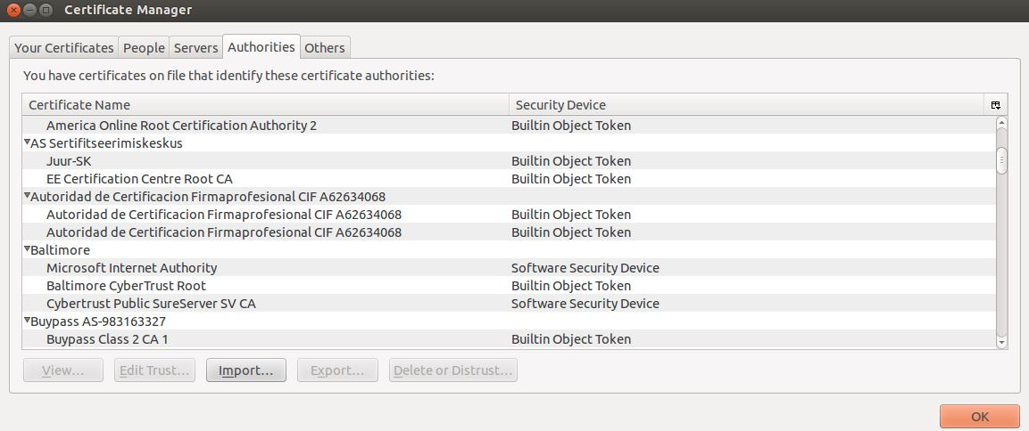

SSL Observatory Project 2010

* Firefox contains up to 124 trusted root CAs by default
* Results in up to 1,482 trustable CA certificates and 651 Organizations
* Other browsers such as Internet Explorer have many more

**An available extension**

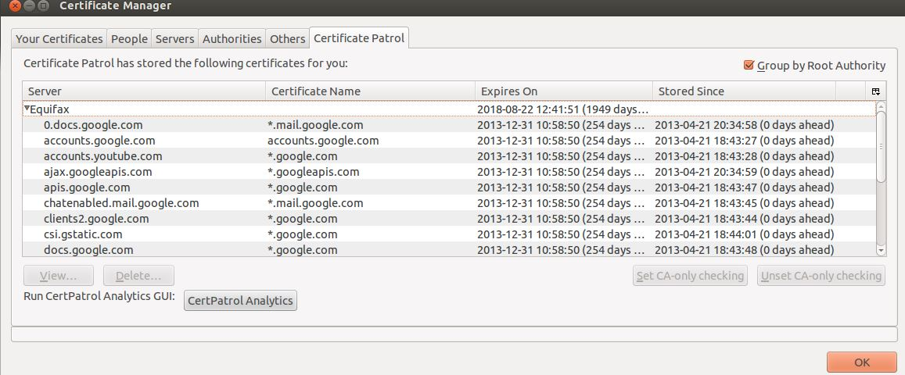

CertPatrol

* Starts with a “blank slate”
* Notifies user when a new certificate is accepted
* User may choose to reject the certificate
* Contains only User accepted certificates

**Analyzing CertPatrol**

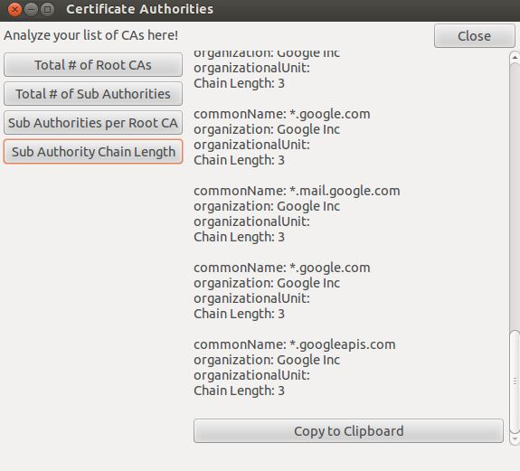

CertPatrol Analytics

* New GUI features added to CertPatrol
* Enhanced functionality to gather data
* Gather insight with User’s CA Statistics